School Uniform Policy

Bridge Junior School
(part of the Attenborough Learning Trust)
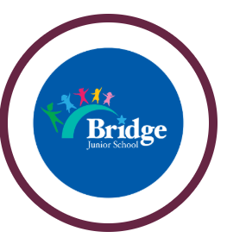

Approved by: | Jason Williamson | Date: January 2025
Last reviewed: | December 2023
Next review due by: | January 2027

Aims

Following a thorough consultation with our parents, Bridge Junior School is introducing a whole school uniform.
The key aims at Bridge for introducing a uniform are:
- To create a greater sense of community cohesion, and promotes the idea that we are all the same and equal.
- To develop a ‘uniqueness’ based on their individual characters/ personalities not by what our children wear.
- Increase safety so that our children belong to the same school family in the same colours. This can be extended to out of school trips and events.
- To associate a uniform with a greater affinity to a positive attitude to learning.
- To make clothing more affordable for our parents.
- Most importantly, be proud to represent the Bridge Junior School family.
The children of Bridge Junior have always been excellent ambassadors for the school and we believe that smart school uniform enhances this.

School Uniform

  - Royal blue sweatshirt or cardigan (preferably with the school logo but not essential)
  - Plain white polo shirt
  - Black trousers, black skirt or pinafore dress
  - Plain black school shoes
  - Black or white hijab
  - Black or white taupee
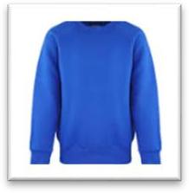
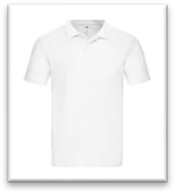
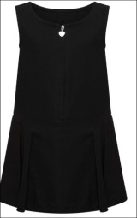
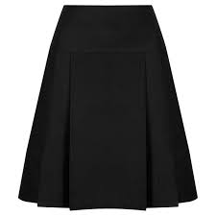
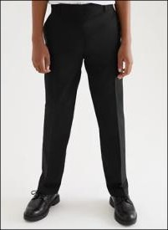
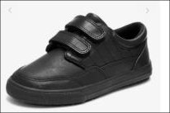
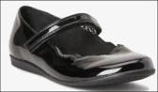

The school appreciates that a school jumper with a logo may be a little more expensive to buy, so a plain royal blue jumper or cardigan is acceptable. Also, there are some occasions when you may be able to make small contribution for ‘lost/unclaimed’ uniform. Please speak to the admin team for more information.

PE Kit:
The children will come to school wearing their PE kit on the days that they have PE.
- plain white t-shirt
- black shorts
- black tracksuit bottoms or leggings
- black plimsolls or trainers
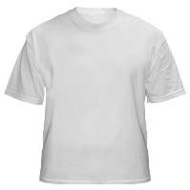
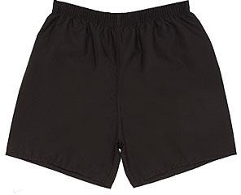
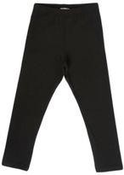
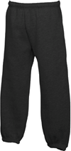
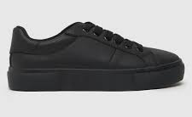
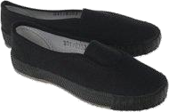

Swimming
Over the academic year, Year 4 will go swimming; this is an essential part of the school curriculum. Swimming caps will be provided by the school. Pupils must provide their own towel.

Boys must wear swimming trunks or shorts of any colour.
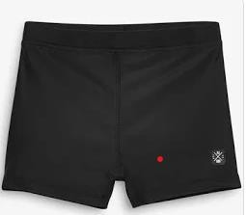
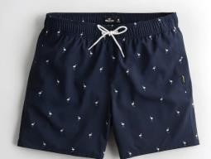
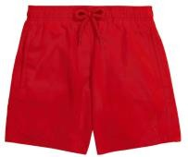

Girls must wear a one-piece swimming costume of any colour.
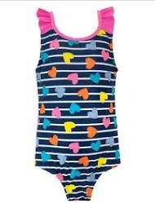
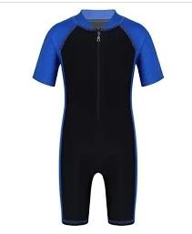
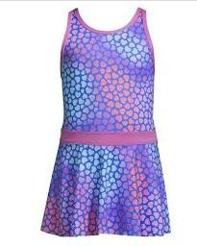

If pupils wish to wear swimwear that covers arms/legs they may do so, however this clothing must be suitable for swimming.

Non-school uniform days
On particular days (such as an individual’s birthday, charity events or religious days) children may wear their own clothes or clothing which complies to the theme of the day (e.g. spots for Children in Need).

Clothing must not display offensive slogans or images.

Hair
Long hair must be tied up especially during PE and sports. The child must be able to do this for themselves or do this at home as staff are unable to help with this. Tying up of long hair also helps to prevent the spread of headlice.

Jewellery
Jewellery should be kept to a minimum in school for health and safety reasons. If earrings must be worn, they must be plain studs. The child must be able to remove these for PE. Staff are unable to help in this. Items of religious significance may be worn but must be covered during PE/sports. Parents must provide the means to cover such items.

All jewellery worn to school is entirely the responsibility of the parent/carers of the child.

Make up
No make-up or nail varnish is to be worn to school.

