
Welcome to Abacus!

Abacus is a maths toolkit that has been written for the new primary maths curriculum. It’s been carefully crafted on a robust approach to creating inspired and confident young mathematicians.
To help children make sense of and practice their maths, Abacus provides a combination of maths games, interactive activities, pupil videos and pupil worksheets, focused around an interactive pupil world where your child can earn rewards and personalise their learning.

Using the Abacus online pupil world with your child
The Abacus pupil world is the place that your child will log into to play maths games, complete interactive activities and access rewards. They earn rewards by completing the games and activities that their teacher has allocated to them. They can also watch pupil videos, which recap key teaching topics. These videos are accompanied by pupil worksheets that help children practice key maths skills.
If you have access to an internet connection, your child can log into the Abacus pupil world at home with their personal login. They can do so via a computer or tablet. Your child’s teacher may give them a login reminder bookmark to keep at home, or in their bookbag, so that they have the information they need to access the pupil world from home.
Logging into the pupil world
The Abacus pupil world is powered by a website called ActiveLearn. To log into the pupil world, your child will need to:
1. Go to www.activelearnprimary.co.uk
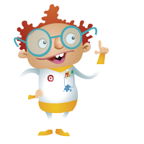
2. Enter their login details and click “Log in”.
Once your child has logged in, they’ll arrive at the Pupil Home. Children can personalise their home screen by choosing a world. The worlds differ depending on key stage but include Race World, Skate World and Future World.
“My Stuff”
This is where children can see the activities their teacher has allocated to them. They can see here how many coins each game or activity is worth before completing it.

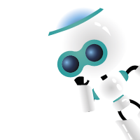
“My Rewards”
‘My Rewards’ is where your child can go to select their rewards after completing allocated games and activities. They can also customise avatars, decorate a tree house, play games and more. The more games and activities your child completes, the more rewards they can unlock and buy.

Need help?
Don’t forget, if your child is having trouble using the pupil world, help can be found in the Help Section of ActiveLearn (in the top right-hand corner of the website).
Please note: We strongly recommend using Google Chrome or Mozilla Firefox web browsers with ActiveLearn. If you prefer to use Internet Explorer, please check you have at least IE9 in order for everything to work as it should.

